| **Name :**  Dyotak Kachare | **Class/Roll No. :**  D11AD/26 | **Grade:** |
| --- | --- | --- |

**Title of Experiment :**

Introduction to platforms such as Anaconda, COLAB

**Objective of Experiment :**

To introduce platforms such as Anaconda, COLAB suitable to Machine learning.

**Outcome of Experiment :**

Implement various Machine learning models

**Problem Statement :**

Introduction to platforms such as Anaconda, COLAB

**Description / Theory :**

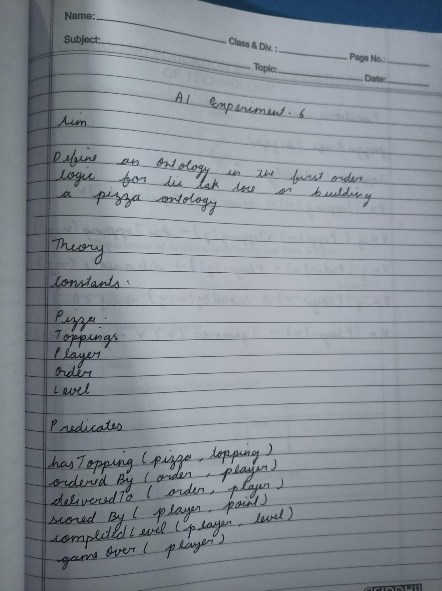

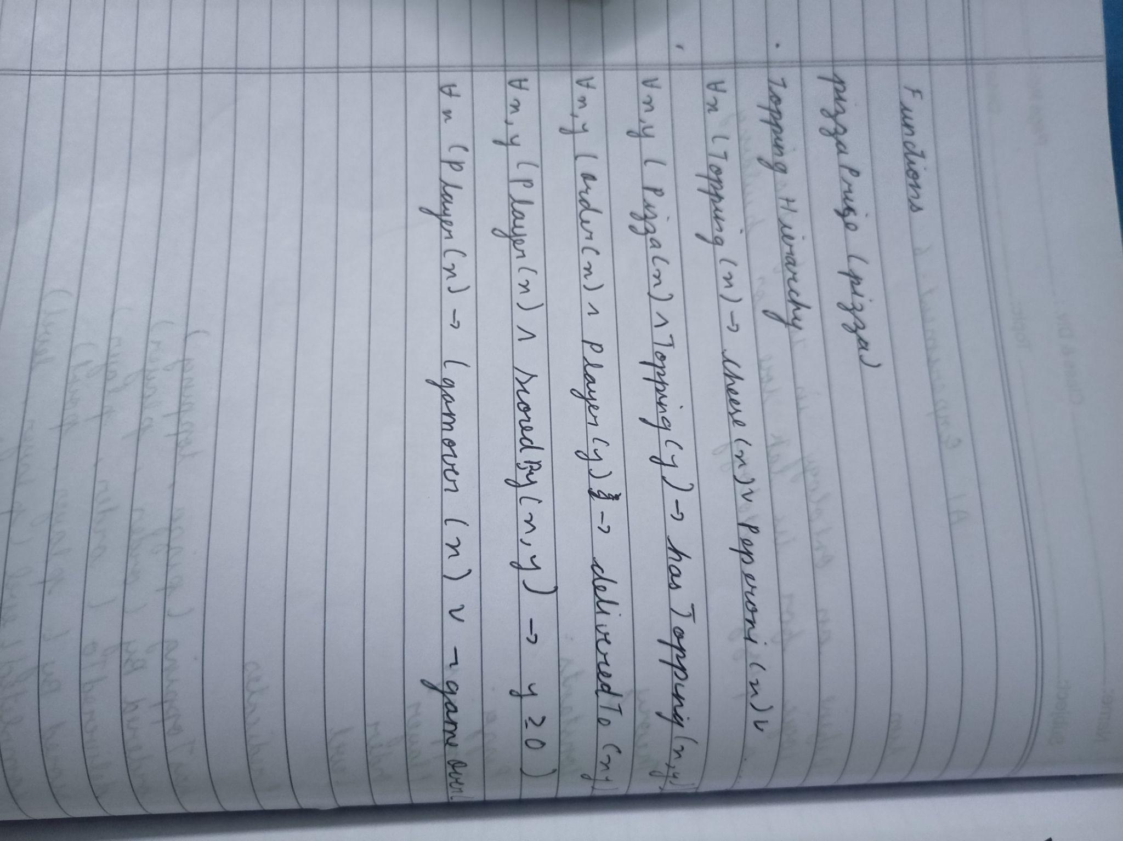

**Code and Output :**

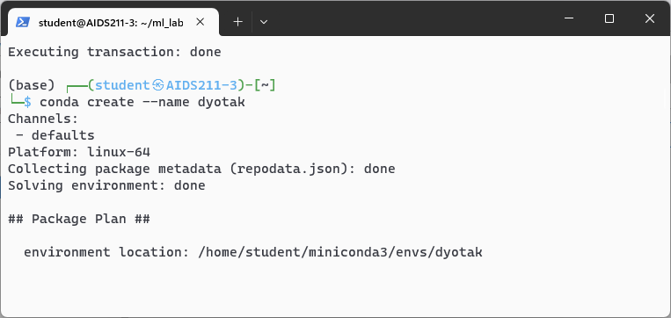

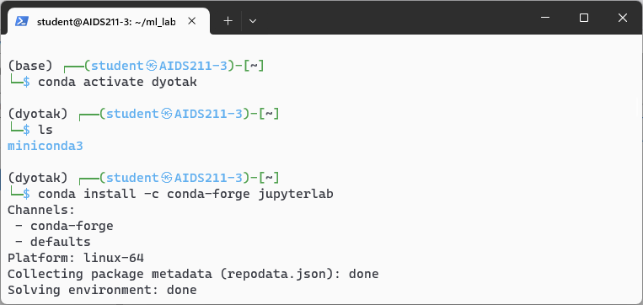

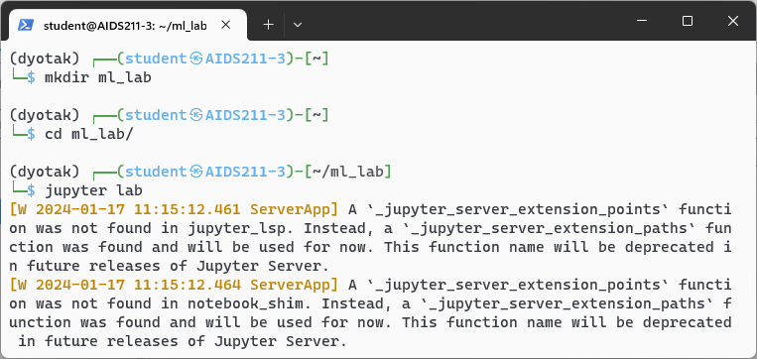

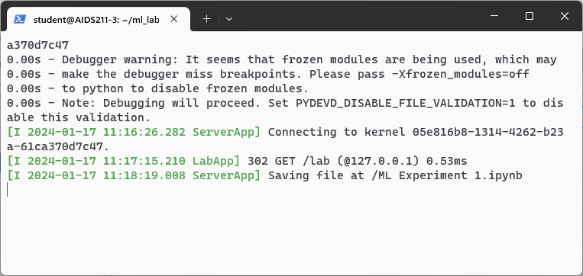

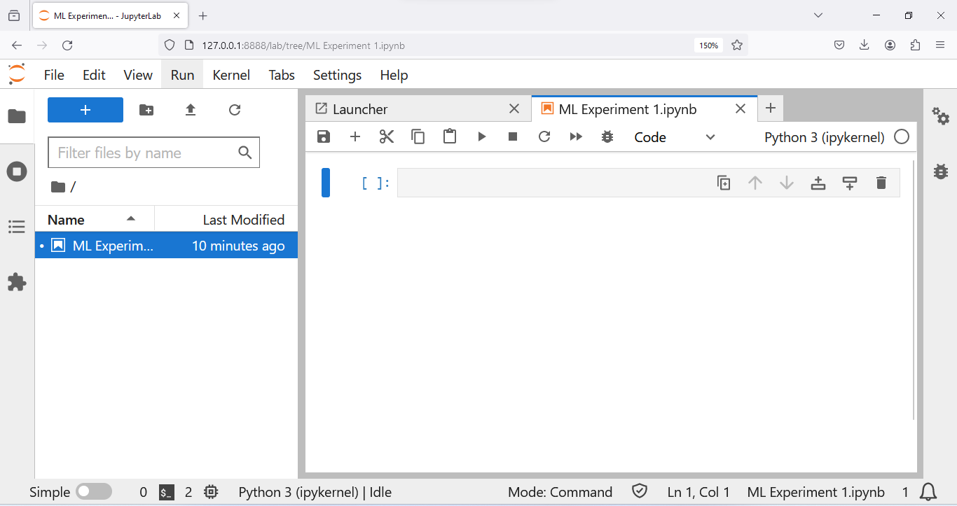

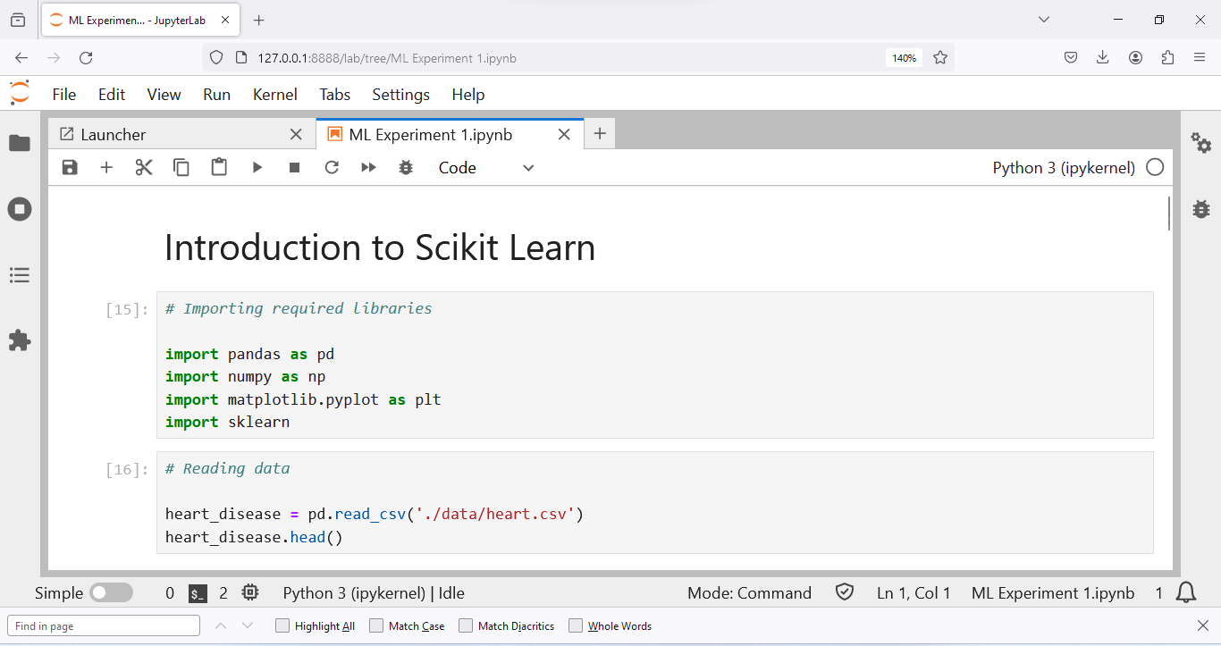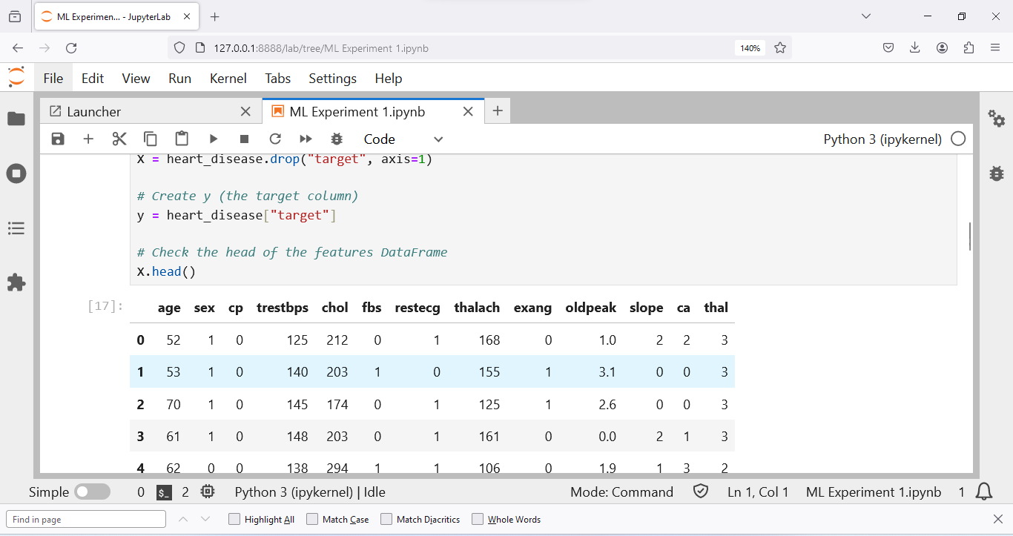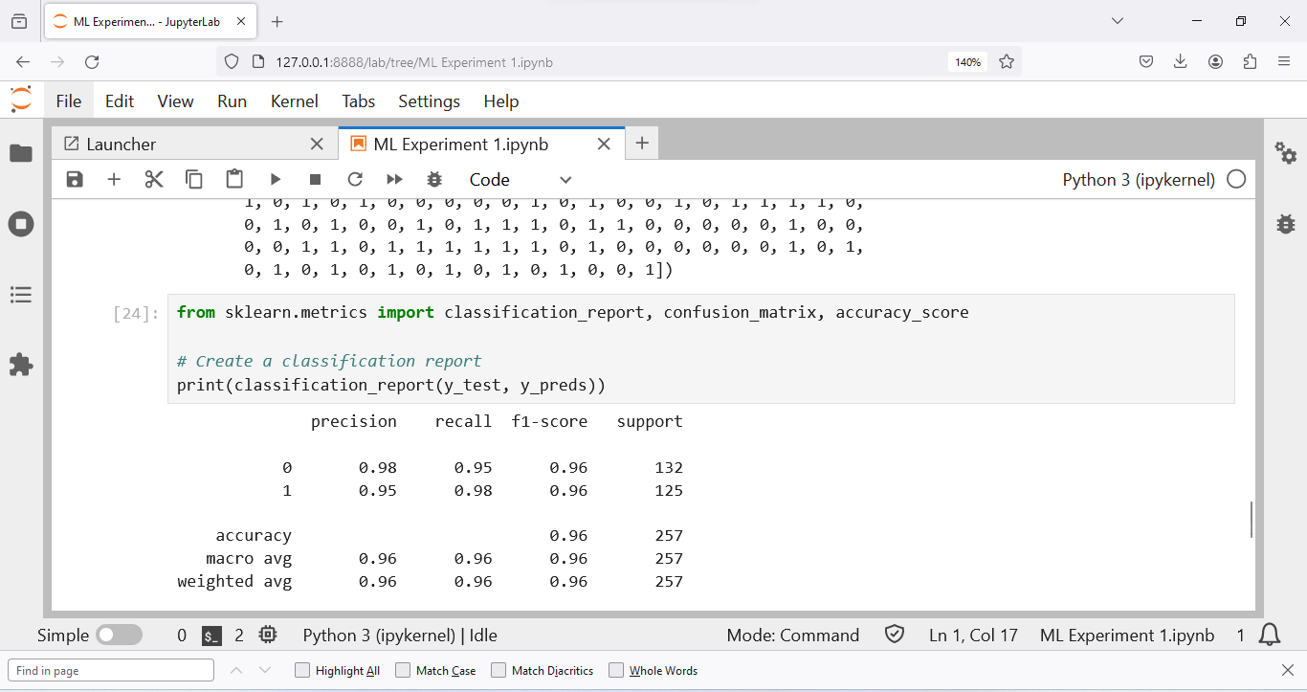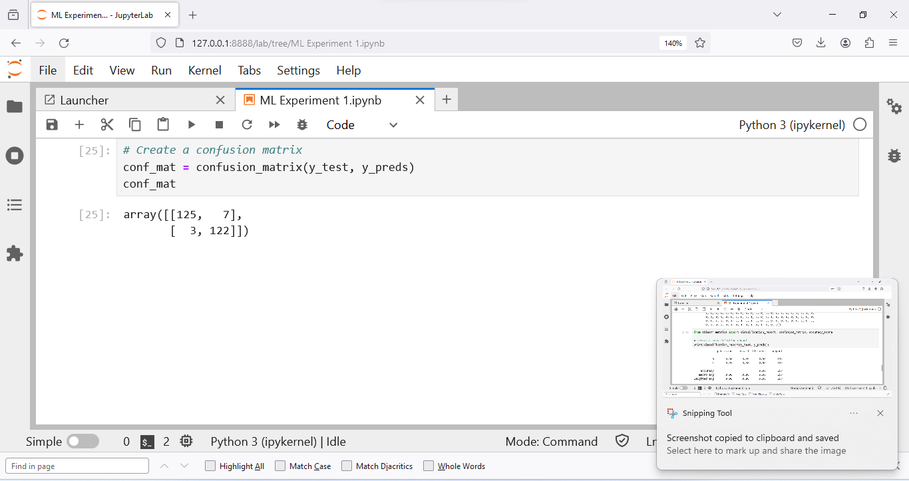

**Result and Discussion :**

Thus we have successfully defined ontology in first-order logic for tic-tac-toe/ building Pizza ontology.